
SEMESTER A251
SQIT5043 PROGRAMMING FOR ANALYTICS
INDIVIDUAL ASSIGNMENT 1

MALAYSIAN TAX CALCULATOR
(Python Program)

Name: Siti Sarah Binti Mohd Affandi
Matric No: 835555
Lecturer: Assoc. Prof. Dr. Aida Mauziah Benjamin

Introduction
This program is a Python-based Malaysian Tax Calculator that allows users to register, log in, and calculate their income tax based on Malaysian progressive tax rates.
It is designed to simplify the process of estimating personal tax payable after considering tax reliefs. The system stores user profiles and tax records for future reference, ensuring a personalized and reusable experience.
This project was developed as part of the Programming for Analytics course to demonstrate practical skills in writing modular Python programs, handling data files, and designing simple user interactions.

Objective
The main objectives of this project are:
- To develop a simple tax calculator that follows Malaysian tax rules.
- To store and manage user registration using CSV files.
- To provide automated tax computation based on user income and relief.
- To enable data retrieval for users to view their previous tax calculation history.

Background
The program is written in Python using fundamental programming concepts such as:
- Conditional statements (for login, validation, and tax brackets).
- Functions and modular design (separated into main.py and functions.py).
- File handling using CSV (to save user data and tax history).
- Looping and user input validation (to ensure smooth user experience).
This system mimics a basic taxation system and can be extended into a GUI or web application for practical use.

Methodology / Workflow

4.1 Overview
The development of the Malaysian Tax Calculator follows a modular programming approach and a sequential workflow, starting from user registration to tax computation and record management.
Two Python modules were designed:
- main.py: Handles user interaction, input validation, and overall program control flow.
- functions.py: Stores all reusable functions such as user verification, registration, tax computation, file saving, and record retrieval.
This modular design promotes clarity, reusability, and easier debugging.

4.2 Flowchart
The following flowchart visually represents the sequential logic implemented in the program, showing user interaction, decision paths, and data processing flow.
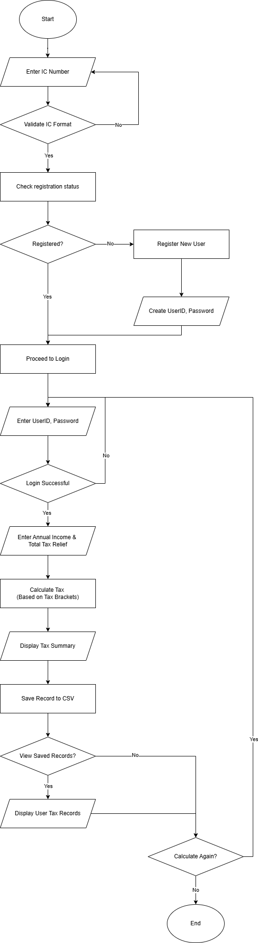
Figure 1: System Flowchart of the Malaysian Tax Calculator Program

4.3 Process Description
The program workflow consists of five main stages:

Stage 1: User Verification and Registration
- The system begins by requesting the user’s 12-digit IC number.
- Validation ensures the input contains only digits and is exactly 12 characters long.
- The system checks users.csv to see if the user is already registered.
- If not found, the system prompts the user to create a User ID and Password, which are then stored in the CSV file.

Stage 2: Login Authentication
- After registration, the user must log in using their User ID and Password.
- The system validates credentials against stored records in users.csv.
- The password can be the user’s own password or the last 4 digits of their IC for simplicity.
- If authentication fails, the system re-prompts until successful login.

Stage 3: Input of Financial Details
- Once logged in, the user inputs:
  - Annual Income (RM)
  - Total Tax Relief (RM)
- The system includes input validation to ensure numeric values only.
- These data form the basis of the tax computation process.

Stage 4: Tax Calculation Process
- The function calculate_tax() determines:
  - Chargeable Income = Income - Relief
  - Tax Payable using progressive tax rates:
    - 0% for first RM5,000
    - 1% for next RM15,000
    - 3% for next RM15,000
    - 6% for next RM15,000
    - … up to 28% above RM400,000.
- The computed results are displayed in a clear summary showing Chargeable Income and Tax Payable.

Stage 5: Data Storage and Retrieval
- The program automatically saves the user’s latest tax record into tax_records.csv.
- Users are given the option to view all their past records, filtered by their IC number.
- The system outputs a formatted table showing past Income, Relief, Chargeable Income, and Tax Payable.

4.4 Workflow Overview
- Start Program
- Register / Login
- Tax Menu
  - Calculate and Save Tax
  - View Saved Records
  - Logout
- Exit Program

Initial Setup and Configuration

5.1 Software Requirements
- Python 3.10 or higher
- Pandas library
- CSV files (users.csv and tax_records.csv) created automatically by the system.

5.2 Installation Steps
- Install Python from python.org.
- Open terminal or VS Code.
- Install pandas
- Place both files (main.py and functions.py) in the same folder.
- Run program

5.3 Data Files
- users.csv is automatically created when a new user registers.
- tax_records.csv is created when the first tax record is saved.

Basic Operations
Step 1: Launch Program
Run main.py. The system will display:
MALAYSIAN TAX CALCULATOR
Step 2: Register or Login
- If new, you’ll be prompted to register with:
  - IC number
  - User ID
  - Password
- If already registered, proceed to login.
Step 3: Enter Income and Relief
Input your annual income and tax relief amount in RM.
Step 4: View Tax Summary
The system will display:
- Chargeable income
- Tax payable
Step 5: Save and View Records
All calculations are stored in tax_records.csv.
You can view all your past records filtered by IC number.

Troubleshooting and FAQs
Problem | Possible Cause | Solution
Invalid IC message | IC not 12 digits or contains letters | Re-enter IC using digits only
Login failed repeatedly | Wrong password or User ID | Use last 4 digits of IC or correct ID
No records displayed | No previous tax record | Perform at least one tax calculation
CSV file error | File missing or opened elsewhere | Close file before running the program

References
- Lembaga Hasil Dalam Negeri Malaysia (LHDN) — https://www.hasil.gov.my
- Python Software Foundation (2024). Python 3 Documentation. https://docs.python.org/3/
- Pandas Development Team (2024). Pandas User Guide. https://pandas.pydata.org/docs/

